E-PROJECT DOCUMENTATION



**GROUP MEMBERS**

“Syed Muhammad Danish, Student: 1340587”

“Muhammad Hamza Sohail, Student: 1340542”

“Muhammad Ahsan, Student: 1343003”

**FACULTY :** AATIKA LIAQUAT

**BATCH CODE : 2110C1**

**CURRICULUM : 6672**

**TABLE OF CONTENT**

ACKNOWLEDGMENT

ABSTRACT

CARTIFICATION

**CHAPTER NO # ONE OVERVIEW**

**1.0 NEED OF PROJECT**

**1.1 PROBLEM DEFINATION**

**CHAPTER NO # TWO DEVELOPMENT AND BACKGROUND**

**2.0 PROJECT DURATION**

**2.1 TASK SHEET**

**CHAPTER NO # THREE HARDWARE AND SOFTWARE**

**3.0 HARDWARE**

**3.1 SOFTWARE**

**CHAPTER NO # FOUR CONCLUSION AND REMARKS**

**4.1 SNAP SHOTS**

**4.1 submission checklist**

**4.2 conclusion**

**ACKNOWLEDGMENT**

We are writing this to declare that all the work which is being written bellow in this Project is a record of our own work submitted to [eprojects@ac.in](mailto:eprojects@ac.in) in the partial fulfillment for the eProject

We also declare that we have not submitted the material being presented in this Project Report for the award of any other thing elsewhere.

We would also want to appreciate the this concept of eProject as it was very helpful tool for us to Polish our capabilities and skills.

And last but not the least we are extremely grateful to the whole faculty and administration of Aptech, for providing us all the facilities that were mandatory, without which this project could not be a success.

**ABSTRACT**

The Topic Of Our Project Was To Develop A Website For NEXT TAG.

It’s Made Using Html and CSS Mainly.  
For Something at Few Points JavaScript and jQuery Is Also Used

**CHAPTER ONE**

**NEED OF PROJECT**

* Some of the benefits of E Project are as under: -
* 1. Re-enforcement of Skills happens in the experiential learning process.
* 2. A mentor, ensuring that you do not get drifted, constantly guides you.
* 3. It gives you a lot of confidence to face an interview as you have worked on a project. You can explain virtually everything on the subject you have learnt.
* 4. A nice, final, black, hardbound report adds to you credentials and enhances your job prospects.
* E Projects is compulsory (Sem-End Project) and is supposed to be done over and above the assignments given in your course books.
* It is advised that if a student follows the projects and submits assignments he would definitely have an edge over other students.
* Students need to submit their project report along with working application and source code in the stipulated time.

**Projects will be evaluated.**

E Project is a step by step learning environment that closely simulates the classroom and Lab based learning environment into actual implementation. It is a project implementation at your fingertips!! An electronic, live juncture on the machine that allows you to

* Practice step by step i.e. laddered approach.
* Build a larger more robust application.
* Usage of certain utilities in applications designed by user.
* Single program to unified code leading to a complete application.
* Learn implementation of concepts in a phased manner
* Enhance skills and add value.
* Work on real life projects.
* Give a real life scenario and help to create applications more complicated and useful.

Mentoring through email support

**PROBLEM DEFINATION**

UNIVERSAL STATIONARY is selling various types of Stationary items. The company advertises by distributing the pamphlets, advertising on television and so on. Due to rapid development in internet field, the company decides to launch a website where people will get all the information about the various products available with them easily.

**Requirement Specification:**

The Web site is to be created based on the following requirements.

1. The Home Page should be created with proper sections & layout and with a suitable logo.
2. Home Page should contain details of different Stationary items with suitable images.
3. The site should display a menu which will contain the options for brief introduction about the various stationary items available, location of the shop and any other information if required.
4. The information should be categorized according to the brand names of the products like if a User wants to see only “STAPLES” products or any other companies’ products then he/she can click on a Link/button/menu etc. and can see only that Brand products.
5. When a user selects any particular brand, a list of products for that brand will be displayed
6. A brief summary of features of individual products should be displayed on the Web Page along with the product but detailed Features should be stored in Individual Word documents which can be downloaded or viewed by the User who wishes to see the same.
7. The user should also be able to compare the various products of different as well as similar brands.
8. There should be a “Contact Us” page which will have the Address of the Company which is as follows and the mail address which when clicked will invoke the local mail client from where they can send an email.

**Chapter TWO**

**PROJECT DURATION**

1. Analysis -5 DAYS.
2. Design – 17 DAYS.
3. Development – 8 DAYS
4. Documentation – 2 DAYS

**TASK SHEET**

|  |  |  |  |  |  |
| --- | --- | --- | --- | --- | --- |
| **No.** | **Task** | **Actual Start Date** | **Actual Days** | **Team Mate Name** | **Status** |
| 1. | Case Study | 3th March 2022 | 2 | Syed Muhammad Danish  Muhammad Ahsan  Muhammad Hamza Sohail | Completed |
| 2. | Graphics Designing | 8th March 2022 | 5 | Syed Muhammad Danish  Muhammad Ahsan  Muhammad Hamza Sohail | Completed |
| 3. | Site Interface Designing | 15th March 2022 | 7 | Syed Muhammad Danish  Muhammad Ahsan  Muhammad Hamza Sohail | Completed |
| 4. | Material Searching | 20th March 2022 | 5 | Syed Muhammad Danish  Muhammad Ahsan  Muhammad Hamza Sohail | Completed |
| 5. | Documentation | 31th March 2022 | 5 | Syed Muhammad Danish  Muhammad Ahsan  Muhammad Hamza Sohail | Completed |

**HOMEPAGE**

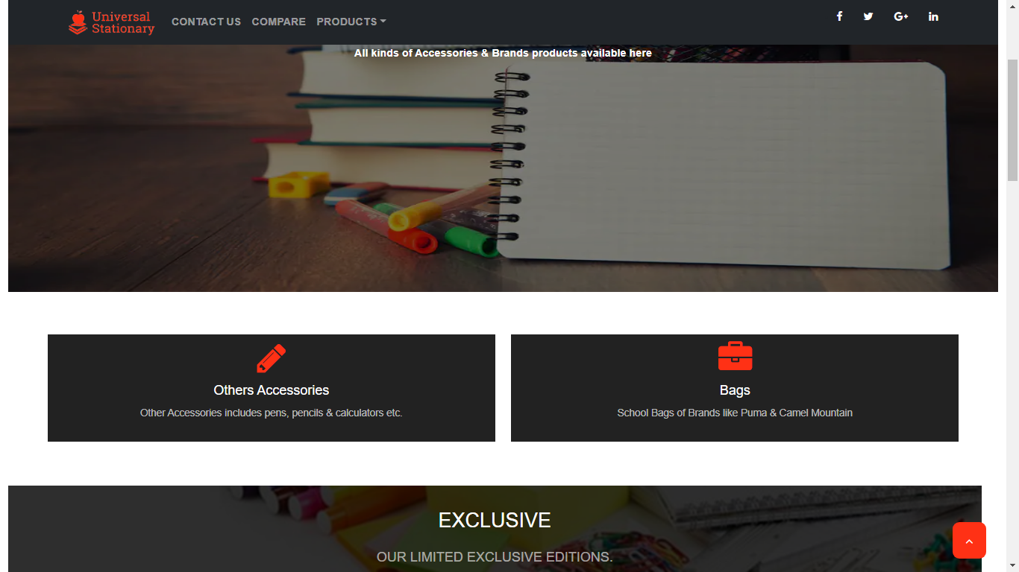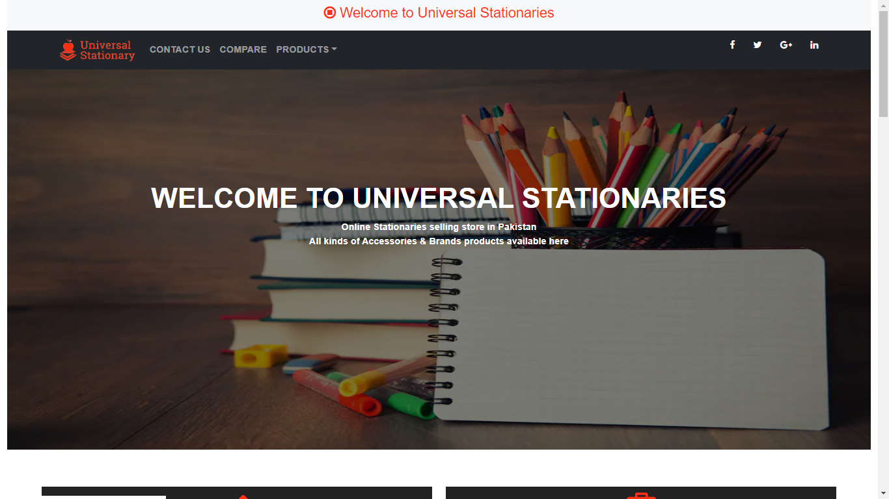

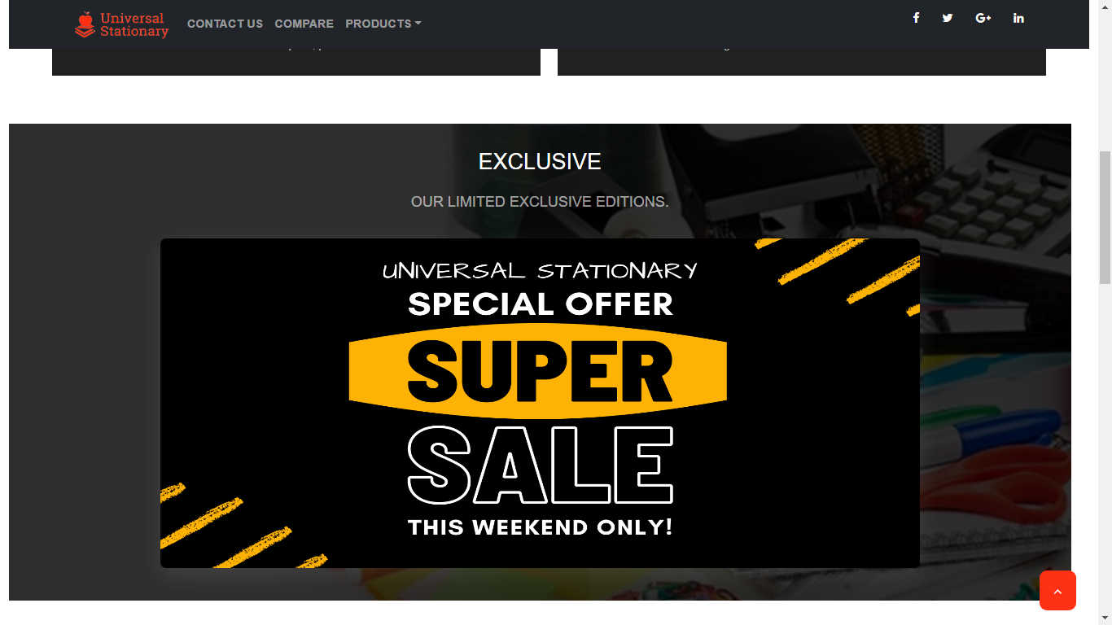

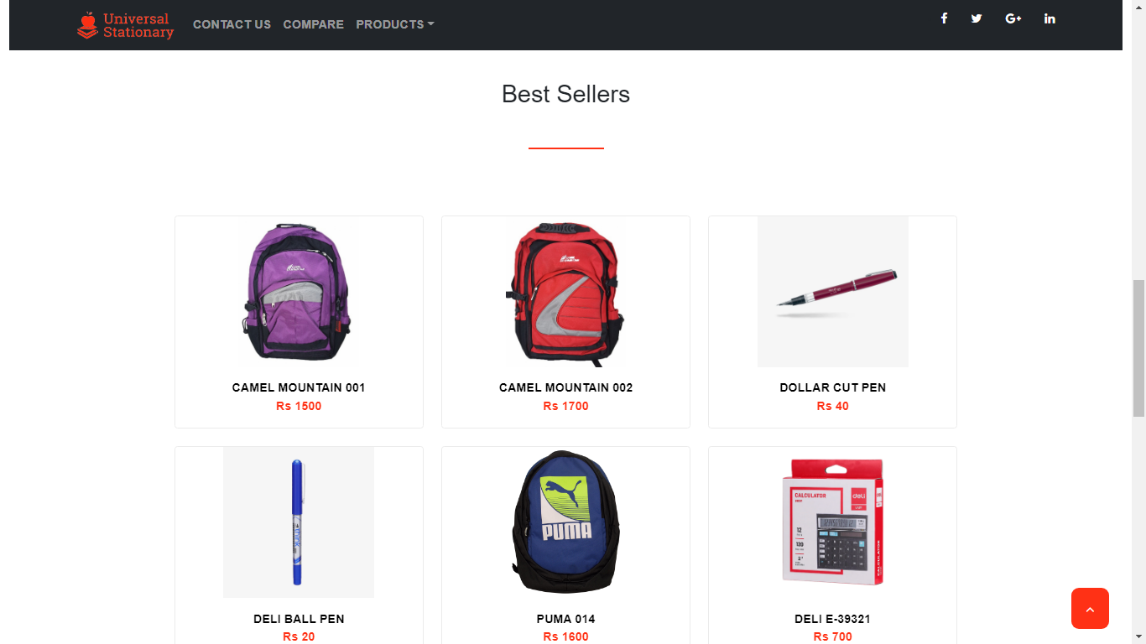

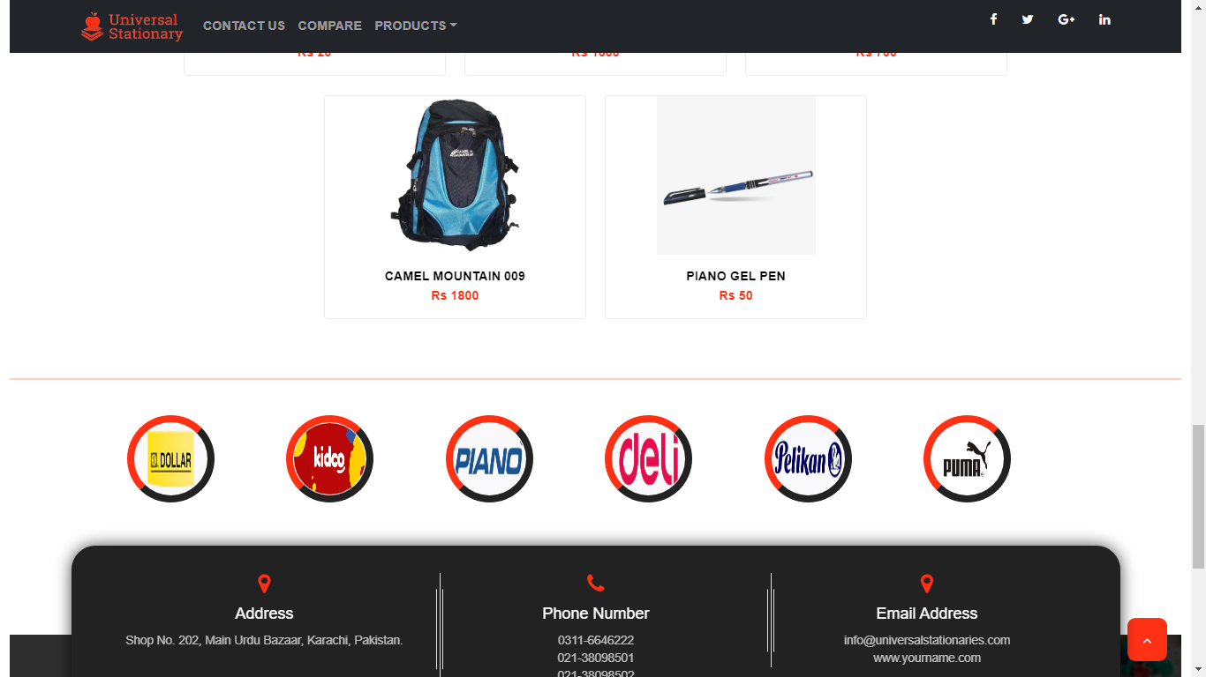

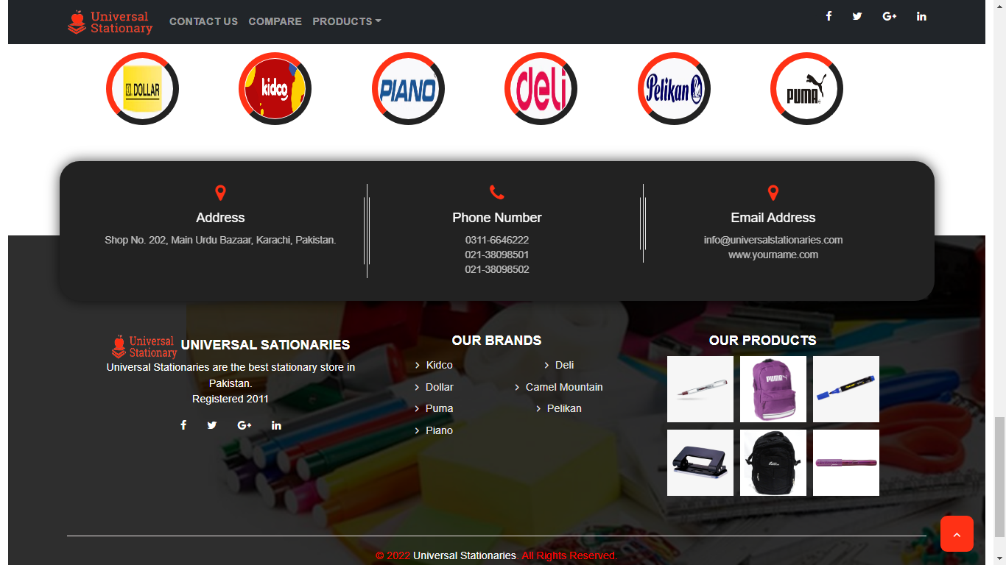

**CONTACT US PAGE**

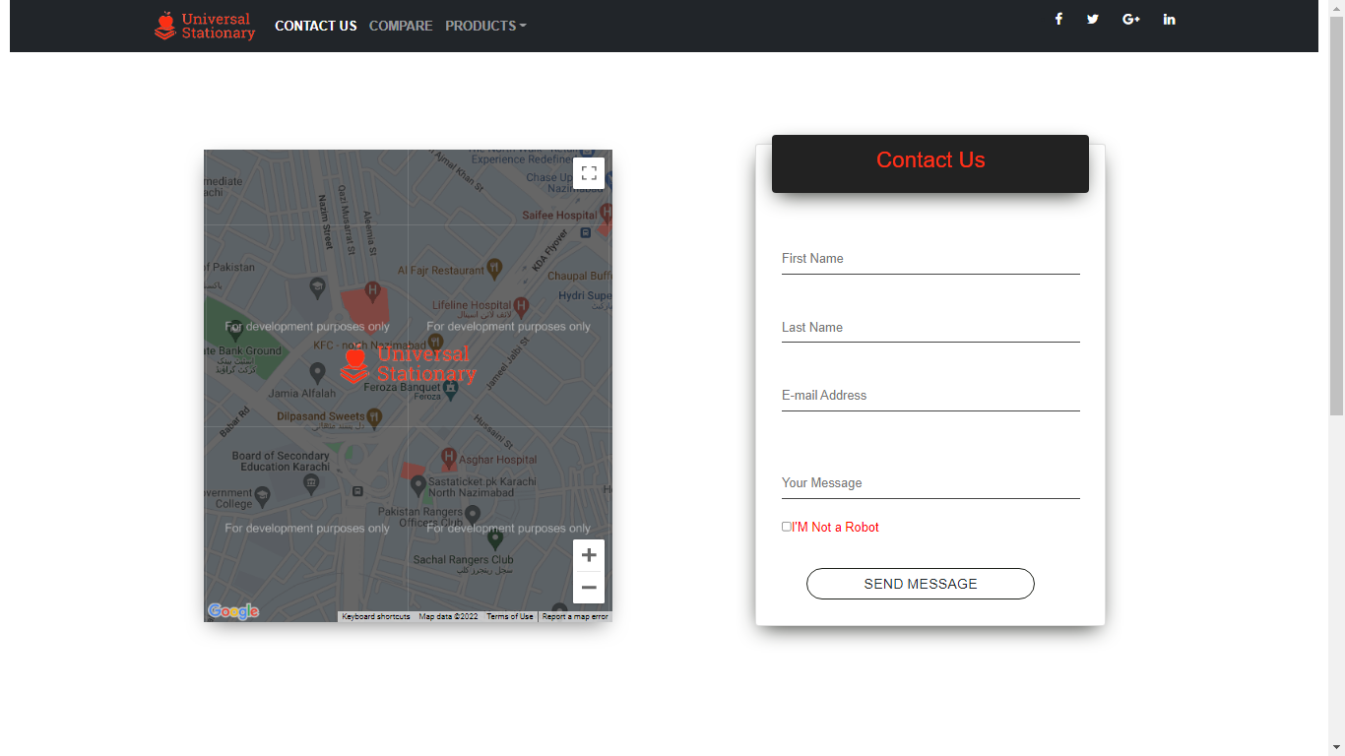

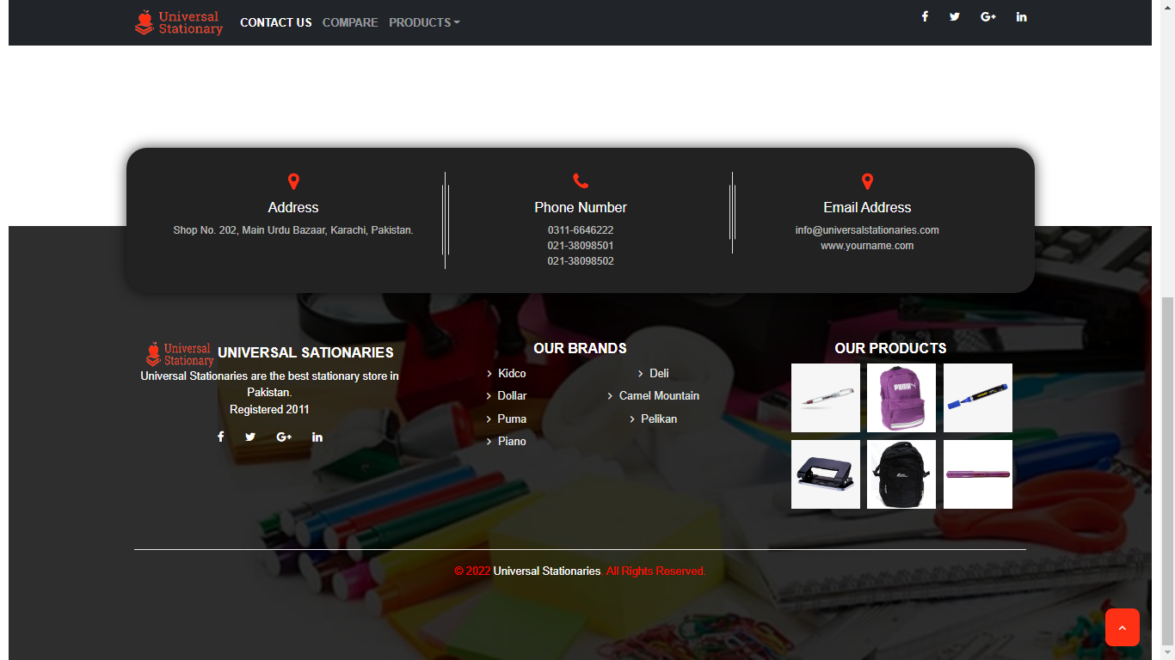

**COMPARE PAGE**

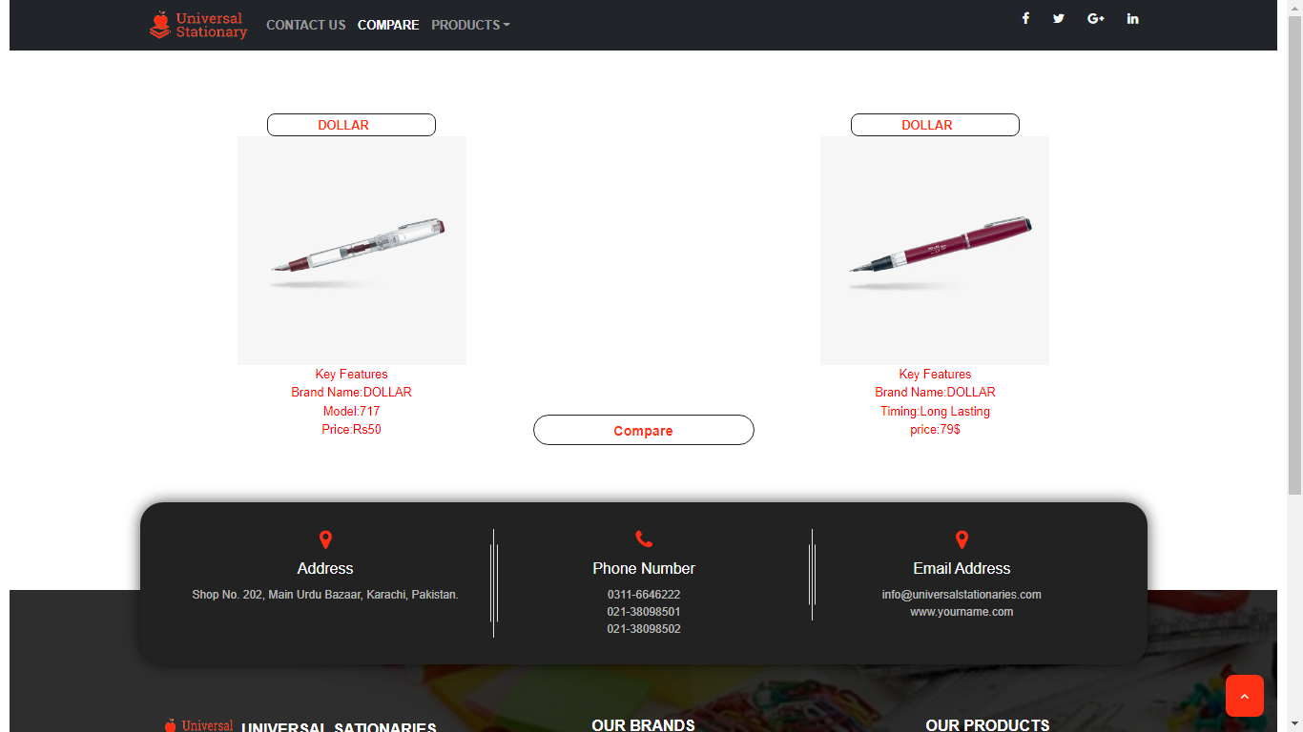

**PRODUCTS PAGE**

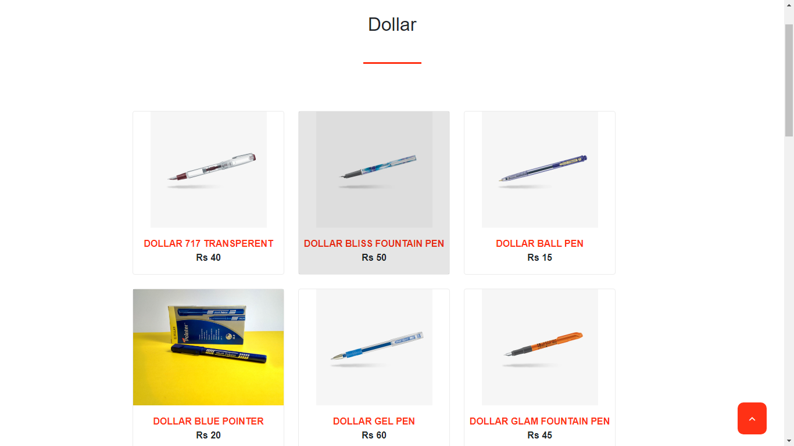

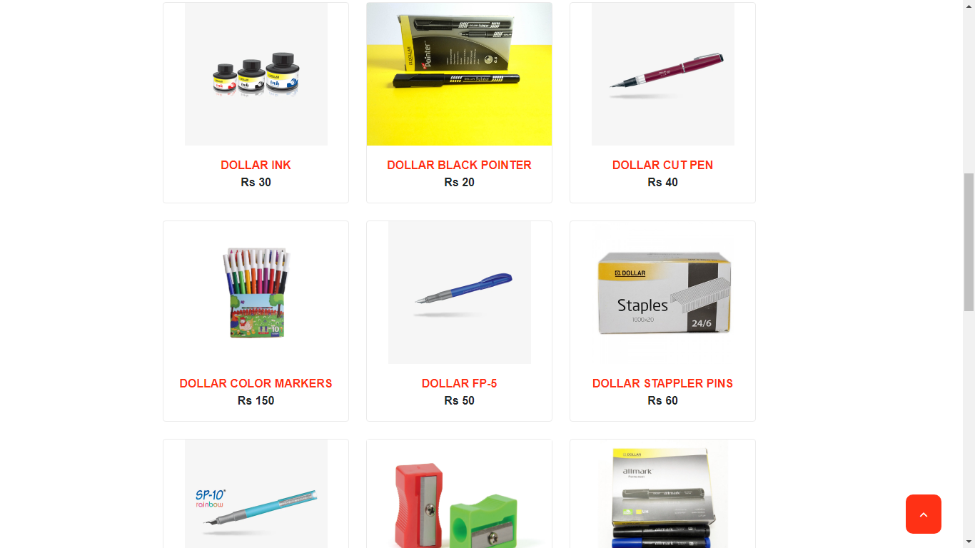

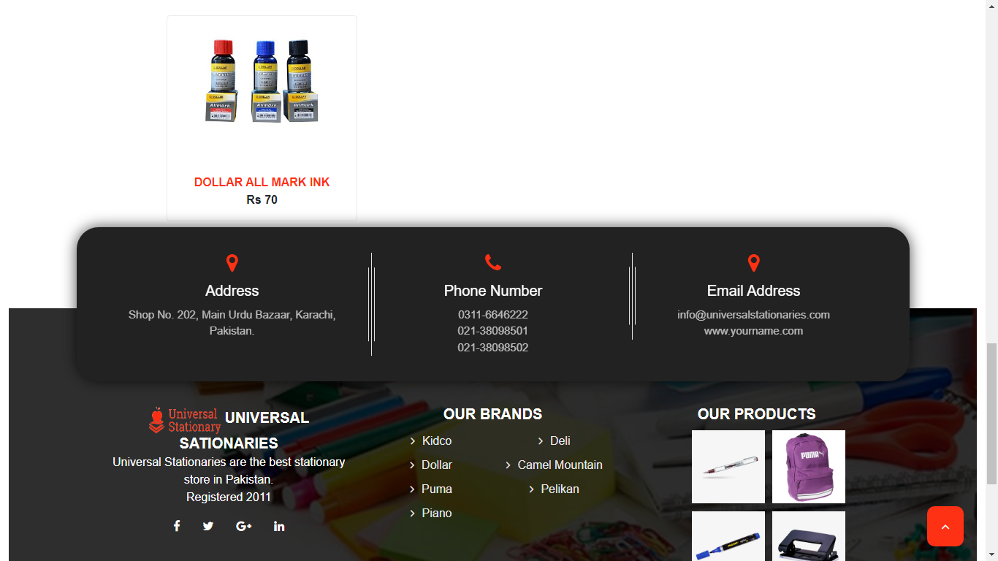

# Submission Checklist

|  |  |  |  |
| --- | --- | --- | --- |
| **S.NO** | **LIST OF ITEMS** | **Remarks** | **COMMENTS** |
| **1.** | **Do All Pages Linked together** | **Yes** |  |
| **2.** | **All Hyperlinks working** | **Yes** |  |
| **3.** | **Page Colors as Per Common Guidelines** | **Yes** |  |
| **4.** | **Site Browser Compatible** | **No** | **Tested in only Chrome** |
| **6.** | **Feedback Form Included** | **Yes** |  |
| **7.** | **Project Zip File** | **Yes** | **Created using WinRAR** |

Note:

Website View All Some Browser:

Internet Explorer

Google Chrome

Mozilla Firefox

**CONCLUSION**

E-Project Was Difficult In The Start But Then As We Started Working On It, We Learnt A Lot Of New Things And, We Learnt To Manage Our Work In Time And Also To Work Under Pressure.